1. Create one IAM user and assign ec2,s3 full access role.

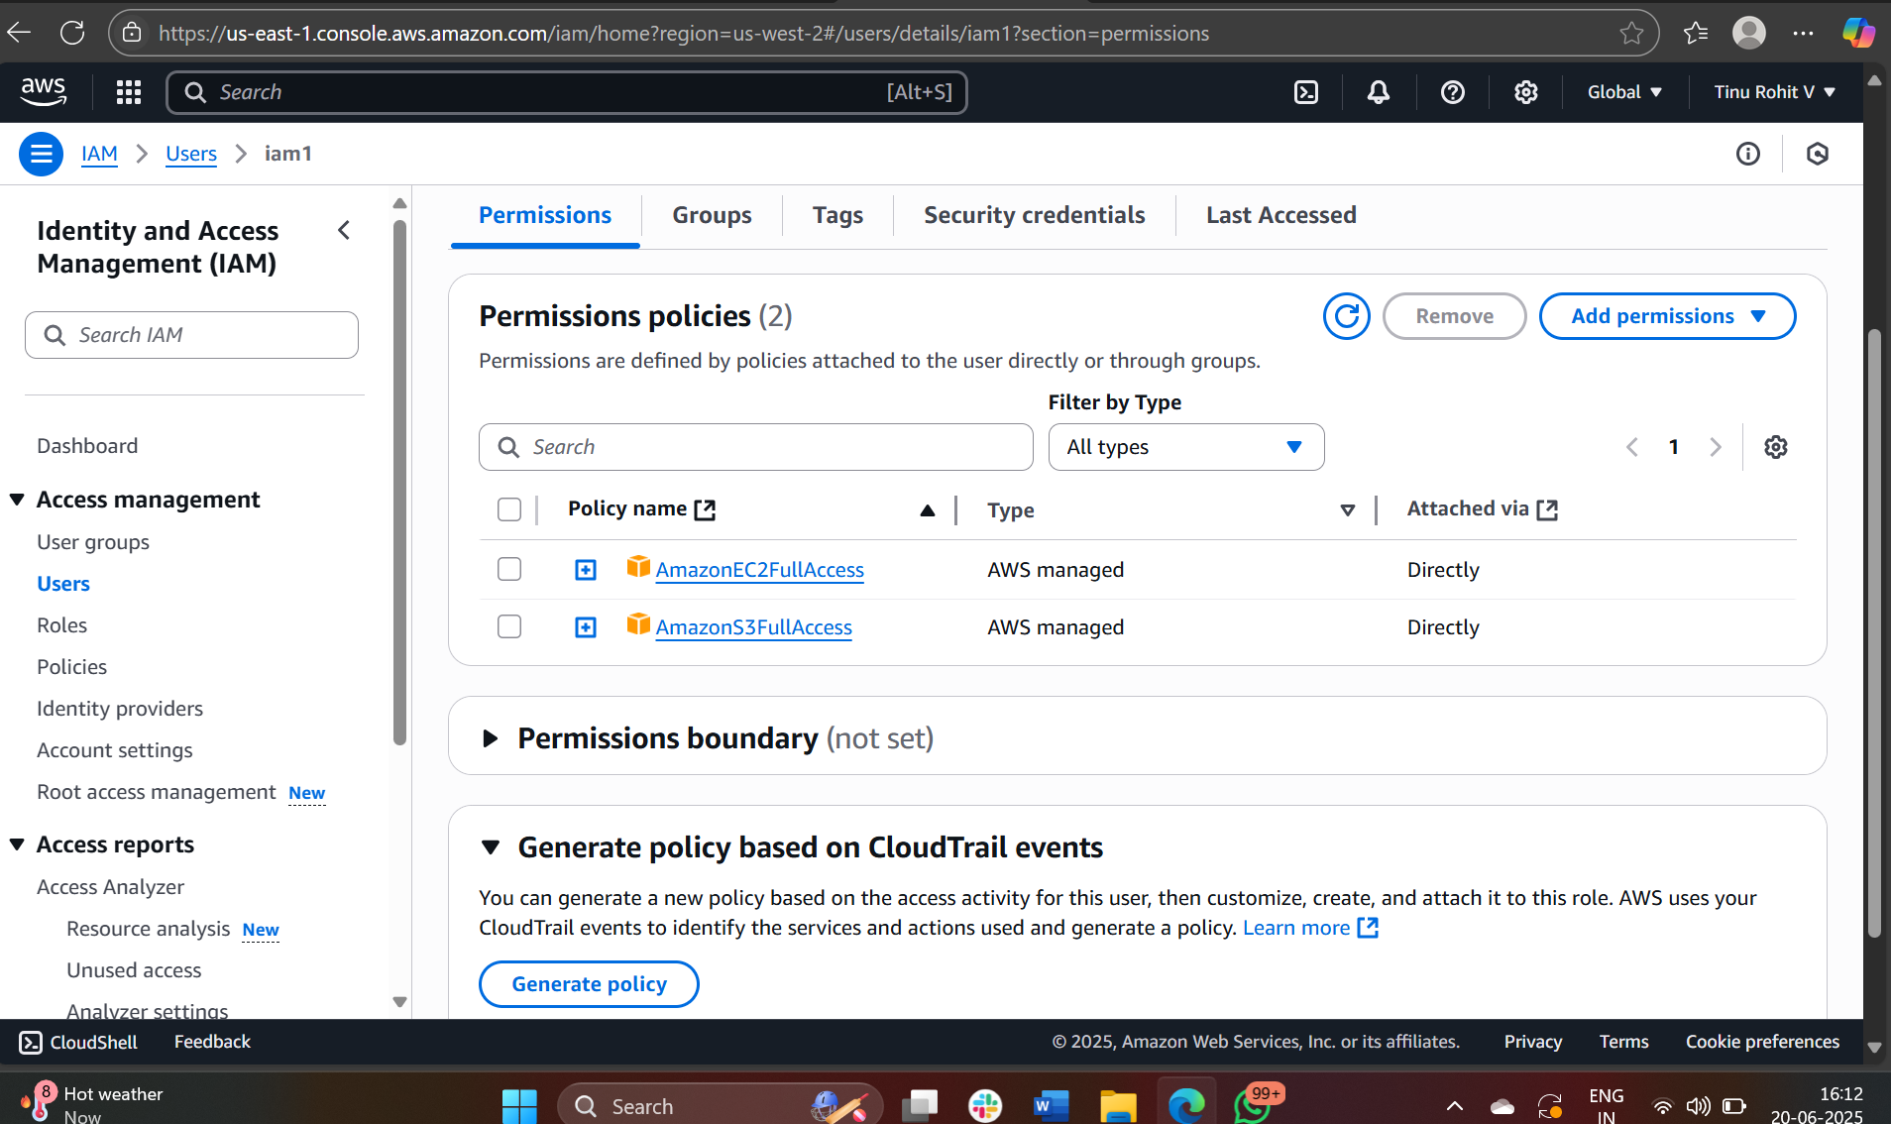

2) Create one Group in IAM and Assign Read access for ec2.

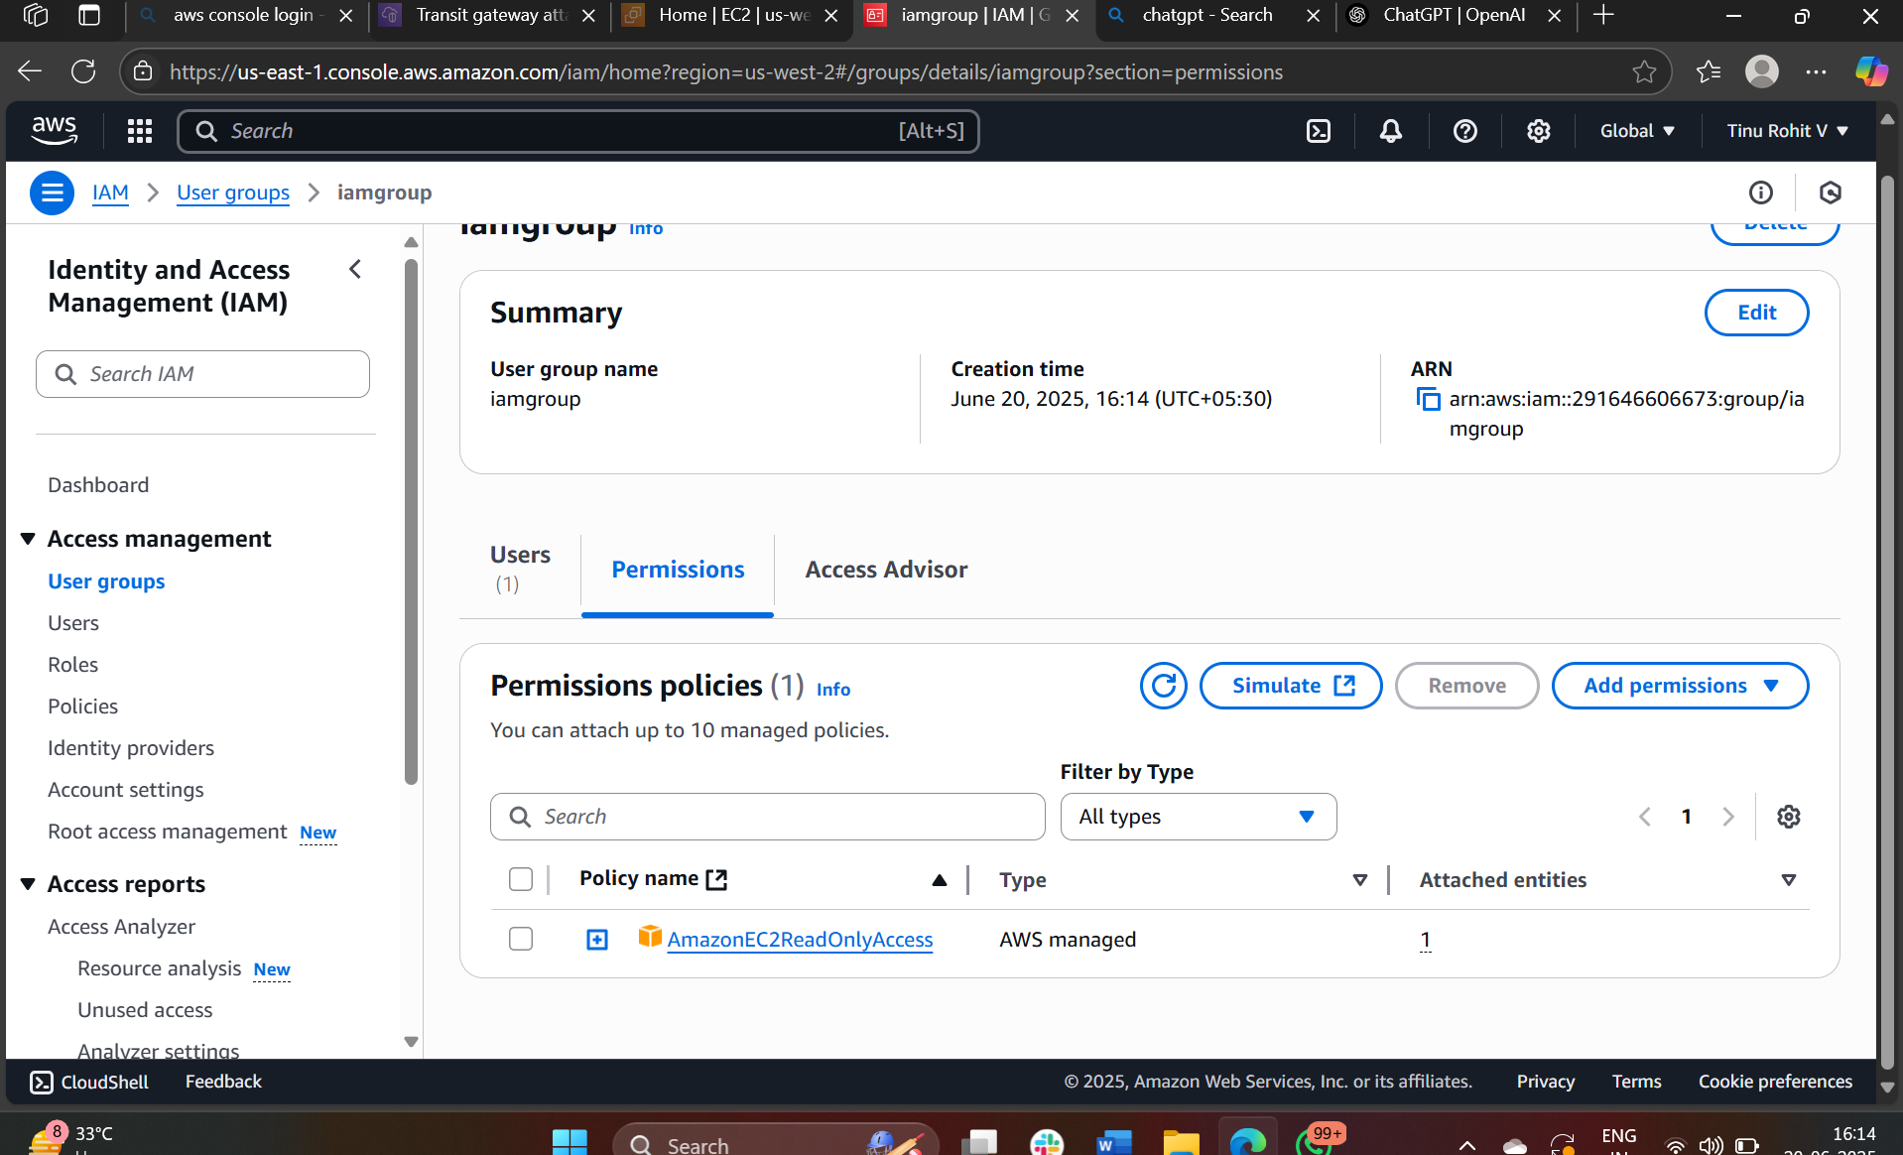

1. Create a new user with name Devops and add to the group created in task2.

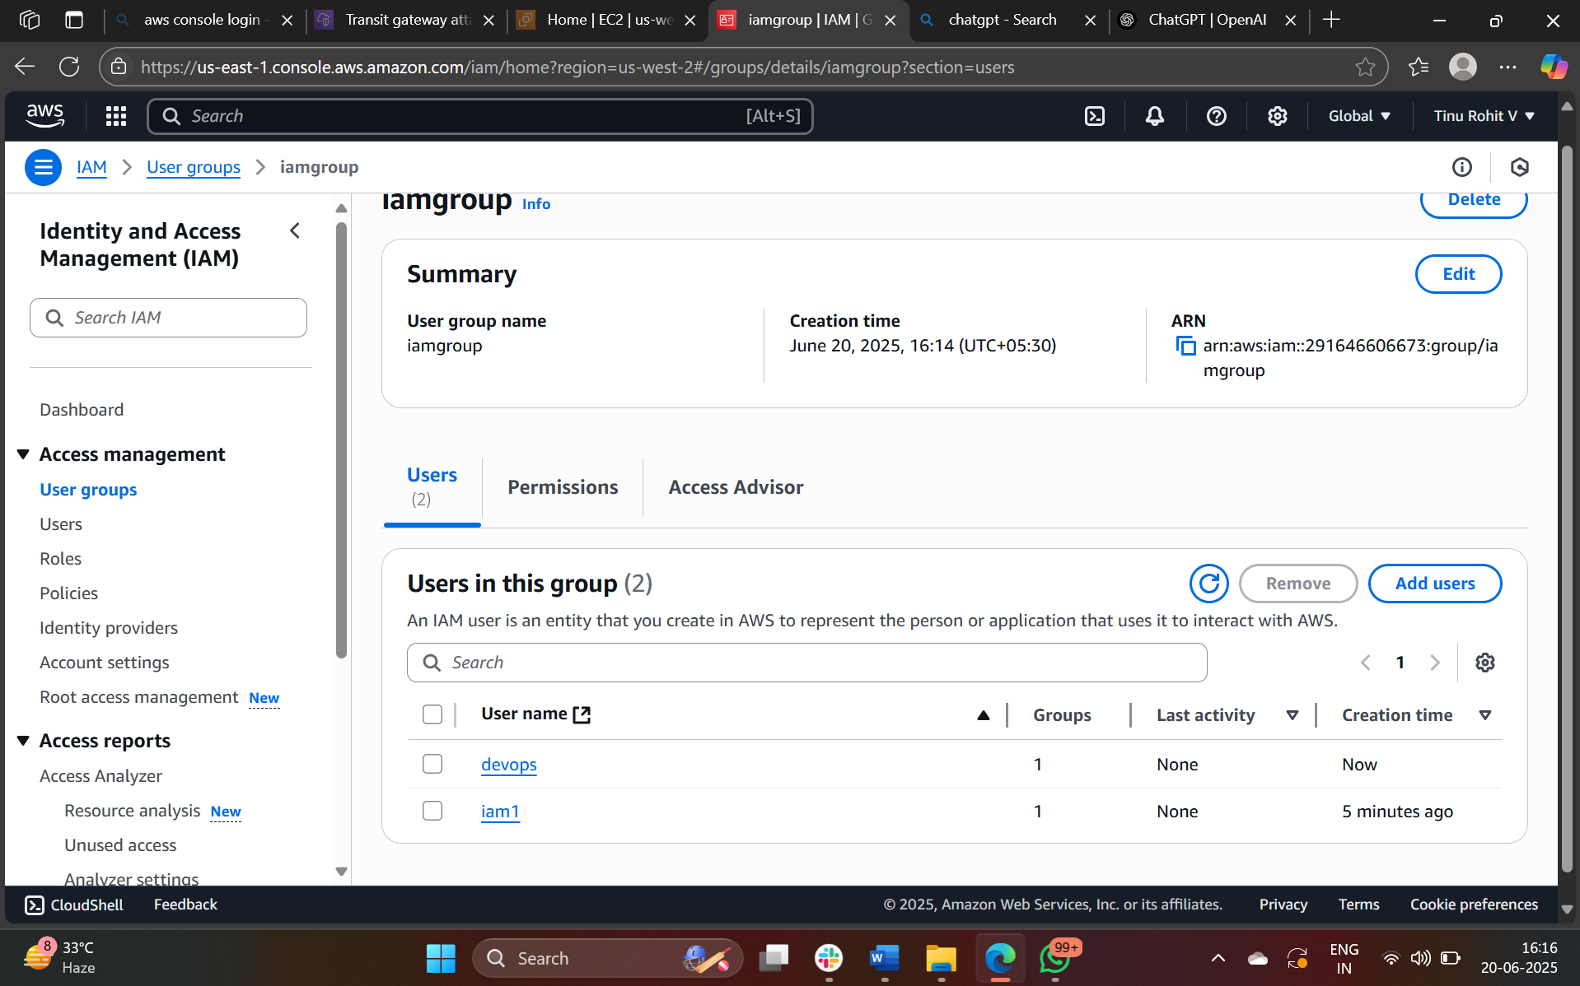

1. Write a bash script to create a IAM user with VPC full access

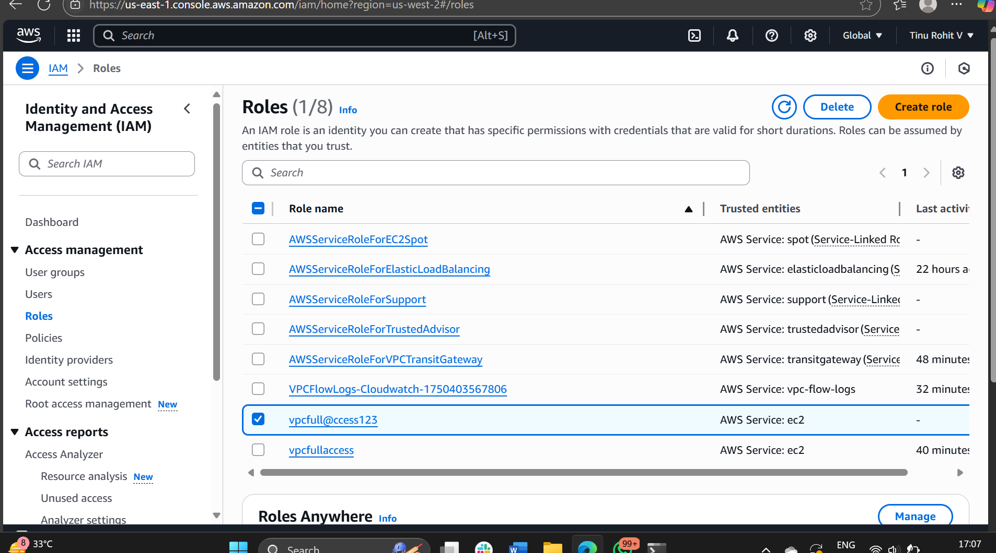

BASH script

#!/bin/bashiam_user="vpc_user"  
policy_name="AmazonVPCFullAccess"# Create IAM user  
aws iam create-user --user-name "$iam_user"# Attach VPC Full Access policy to the user  
aws iam attach-user-policy \  
    --user-name "$iam_user" \  
    --policy-arn arn:aws:iam::aws:policy/$policy_nameecho "User $iam_user created and given $policy_name"

1. Create a IAM policy to access ec2 for a specific user in specific regions only

.

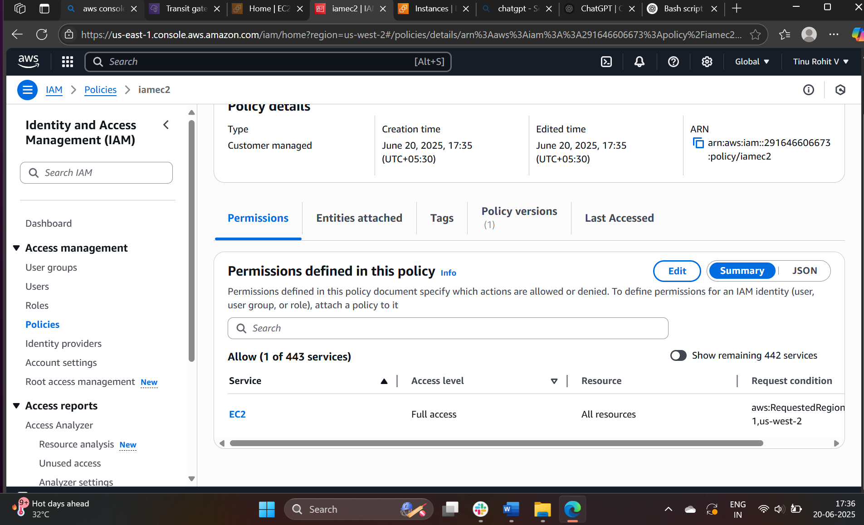

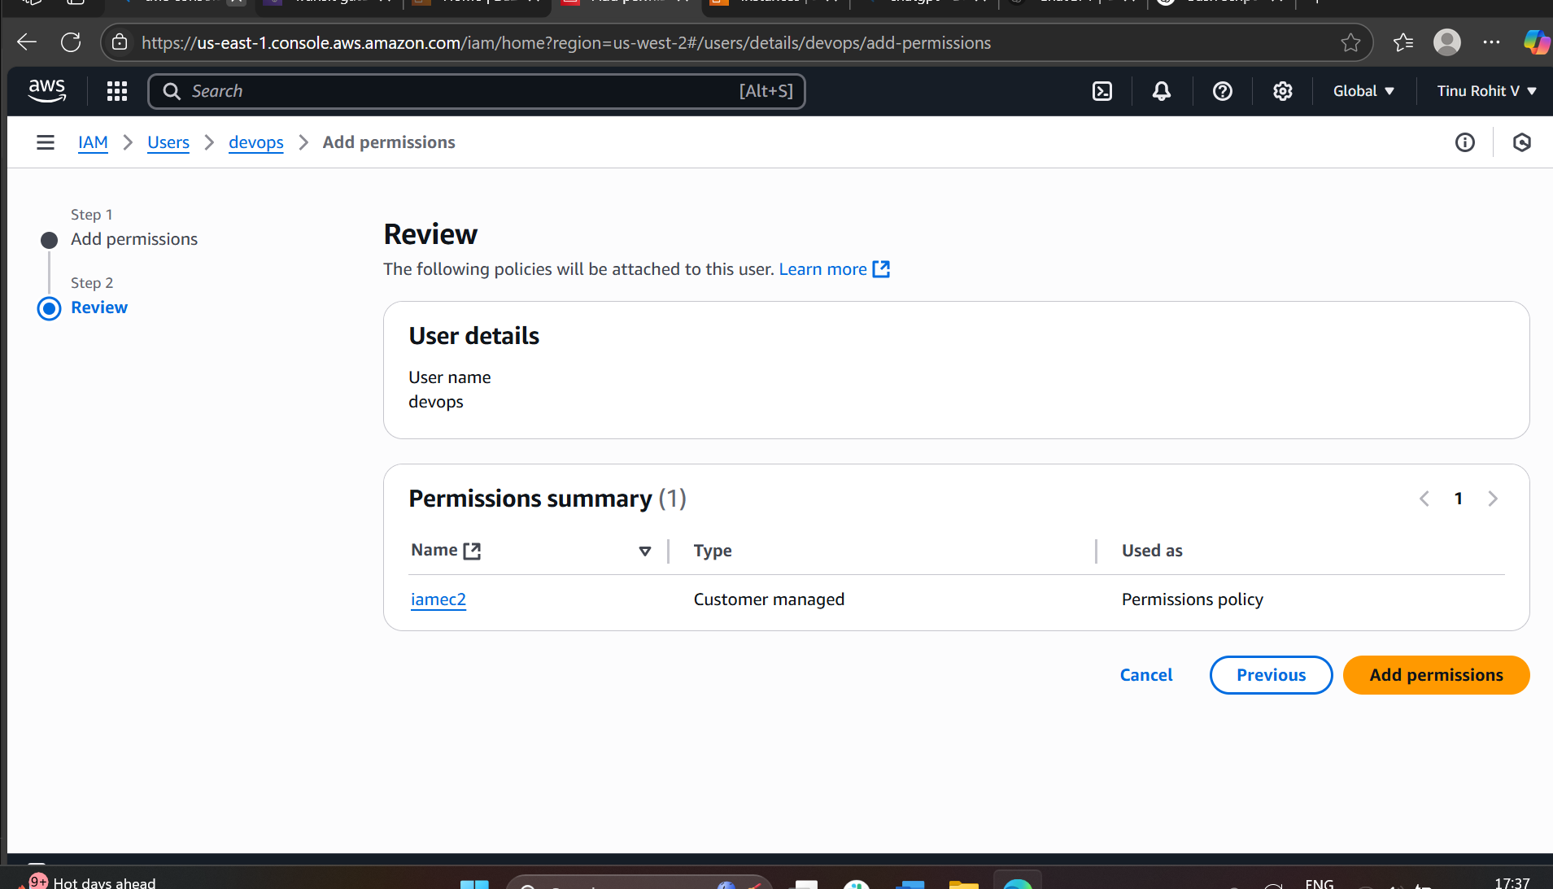

1. We have two accounts Account A and Account B, Account A user should access s3 bucket in Account B. (Collaborate with team member and execute this.Mostly asked in every interview)

